# Lab Report Template for labs 5, 6 and 7 10 marks

Submit on Canvas via the provided link for this lab report.   
For each mistake/error in the code, 10% of the total marks allocated for that question will be deducted.

## Lab 5.1- Reverse Numbers, the Largest and Smallest Numbers 1 mark

Paste your code here as text (not snip):

/*****************************************  
Program title: Reverse numbers   
File Name: project 21.cpp  
Author:Simarpreet singh  
Date:15/10/2022  
Description:Reversing student numbers  
*****************************************/

#include <iostream>

using namespace std;

int main()

{

const int size = 8;//constant size of the array

int num[size];//first array

int rev[size];//secon array

cout << "Reverse numbers" << endl;

cout << "-----------------------------" << endl;

cout << "please enter your student id number :" << endl;//cout statements

for (int i = 1; i <= size; i++)//input the value for the student id number using the conditions of the for loop

{

cout << "Enter number : " << i << "---->";//Enter i number of numbers i=size

cin >> num[i];

}

cout << "Your student ID number is : ";

for (int i = 1; i <= size; i++)//cout numbers entered as a an array together

{

cout << num[i];

}

for (int i = 0; i < size; i++)// for loop to reverse the id number using 2 arrays

{

rev[i] = num[size - i];

}

cout << endl;

cout << "Your reversed number is : ";

for (int i = 0; i < size; i++)//cout the reversed number

{

cout << rev[i];

}

int largest = num[0];

for (int i = 1; i < size; i++)//for loop to get the largest number in the array

{

if (num[i] > largest)

{

largest = num[i];

}

}

int smallest = 2000;// using a very high value for the smallest initialization

//(a value which cannot be the smallest number)

for (int i = 1; i < size; i++)// for loop to get the smallest number

{

if (num[i] < smallest)

{

smallest = num[i];

}

}

cout << endl;

cout << "Your largest number is : " << largest << endl;

cout << "Your smallest number is : " << smallest << endl;

//final cout statements

return 0;

}

Paste the screenshot of your code output here:

## Lab 5.2 Bar Graph 2 marks

Paste your code here as text (not snip)

/*****************************************  
Program title: Bar graph   
File Name: project 22.cpp  
Author:Simarpreet singh  
Date:15/10/2022  
Description:Getting input for a bar graph  
*****************************************/

#include <iostream>

#include<iomanip>

using namespace std;

int main()

{

cout << "Bar Graph (COLUMN CHART)" << endl;

cout << "Please enter 12 numbers,each within the range from 1 to 20\n" << endl;//format

int chart[12];//array for bar graph

int size;

for (size = 0; size < 12; size++)//for loop

do

{

cout << "Enter a number " << size + 1 << " ----->";

cin >> chart[size];

if (chart[size] < 1 || chart[size]>20)//if the enetered number is outside limits the message will be displayed

{

cout << "Invalid Number" << endl;

}

} while (chart[size] < 1 || chart[size]>20);//while loop to get input until correct

cout << "Bar Graph (COLUMN CHART)" << endl;

int row;

for (row = 20; row > 0; row--)//starts from last row and decreases in increments of 1

{

cout << " " << fixed << setw(3) << row;//set width of the output

for (int c = 0; c < 12; c++)// nested for loop to display 2d array

{

cout << " ";

if (chart[c] >= row)//if criteria not met display statement

{

cout << fixed << setw(3) << "*";

}

else // otherwise dispaly star

{

cout << fixed << setw(3) << " ";

}

}

cout << endl;

}

for (size = 0; size < 12; size++) //starts from row 1 and increases in increments of one

{

cout << fixed << setw(3) << chart[size];

}

cout << endl;

cout << "END OF PROGRAM";//end of the code

return 0;

}

Paste the screenshot of your code output here:

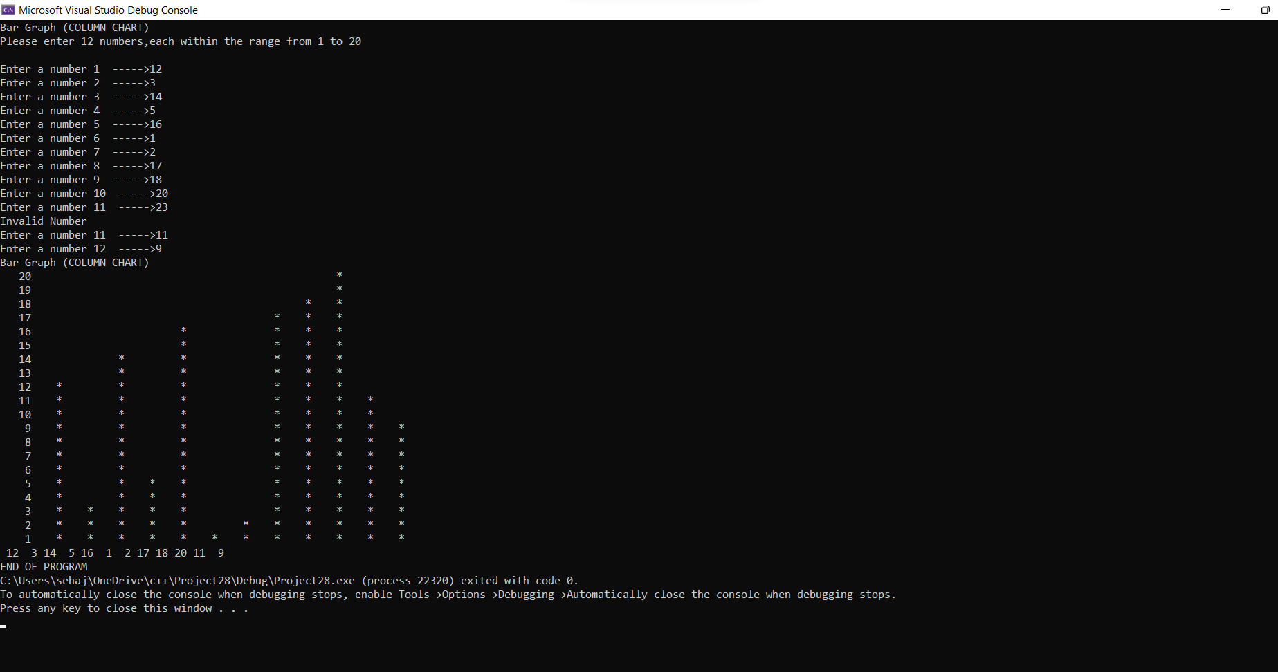

## Lab 6.1-Triangle Solver 2 marks

## Paste your code here as text (not snip)

/*****************************************  
Program title: Triangle solver   
File Name: project 23.cpp  
Author:Simarpreet singh  
Date:16/10/2022  
Description:calculating angles in degrees using the sides of a triangle  
*****************************************/

#define _USE_MATH_DEFINES

#include <iostream>

#include <cmath>

#include<iomanip>

using namespace std;

double InSide(string sideName);

double CalculateAngle(double a, double b, double c);//intializing functions

int main()

{

double a, b, c, A, B, C;//intializing variables

cout << "CALCULATING THE TRIANGLE ANGLES" << endl;

cout << "--------------------------------------" << endl;

cout << "\nINPUTS" << endl;

a = InSide("aa");

b = InSide("bb");

c = InSide("cc");//for 3 sides a b c

if (a + b > c && b + c > a && a + c > b)//if the dimesions of triangle are valid

{

A = CalculateAngle(a, b, c);

B = CalculateAngle(b, a, c);

C = CalculateAngle(c, a, b);//calculate the angles using the sides

cout << "\nTHE ANGLE CALCULATION RESULTS" << endl;

cout << "--------------------------------------" << endl;

cout << "angle A = " <<fixed <<setprecision(1) << A << " Degrees" << endl;

cout << "angle B = " << fixed << setprecision(1) << B << " Degrees" << endl;

cout << "angle C = " << fixed << setprecision(1) << C << " Degrees" << endl;//cout the angles used setprecision to get result to one decimal place

}

else

{

cout << "Error: Invalid Triangle" << endl;//when the triangle is not valid display this

}

cout << "\nEND OF PROGRAM" << endl;

return 0;

}

double InSide(string sideName)//to get triangle side

{

double side;//store variables in side

cout << "Input side " << sideName.c_str() << ": ";

cin >> side;

while (side <= 0)//Will keep looping till the side is more than zero

{

cout << "Error: Invalid input. Enter side greater than zero." << endl;

cout << "Input side " << sideName.c_str() << ": ";

cin >> side;//display error and ask for side agian

}

return side;

}

// function to get sides and calculate angle

double CalculateAngle(double a, double b, double c)

{

double angle;

// calculate angle using given formula

angle = acos((b * b + c * c - a * a) / (2 * b * c));

// convert the angle from radian to degree

angle = angle * 180 / M_PI;

return angle;

}

## Insert the screenshot of the code output here.

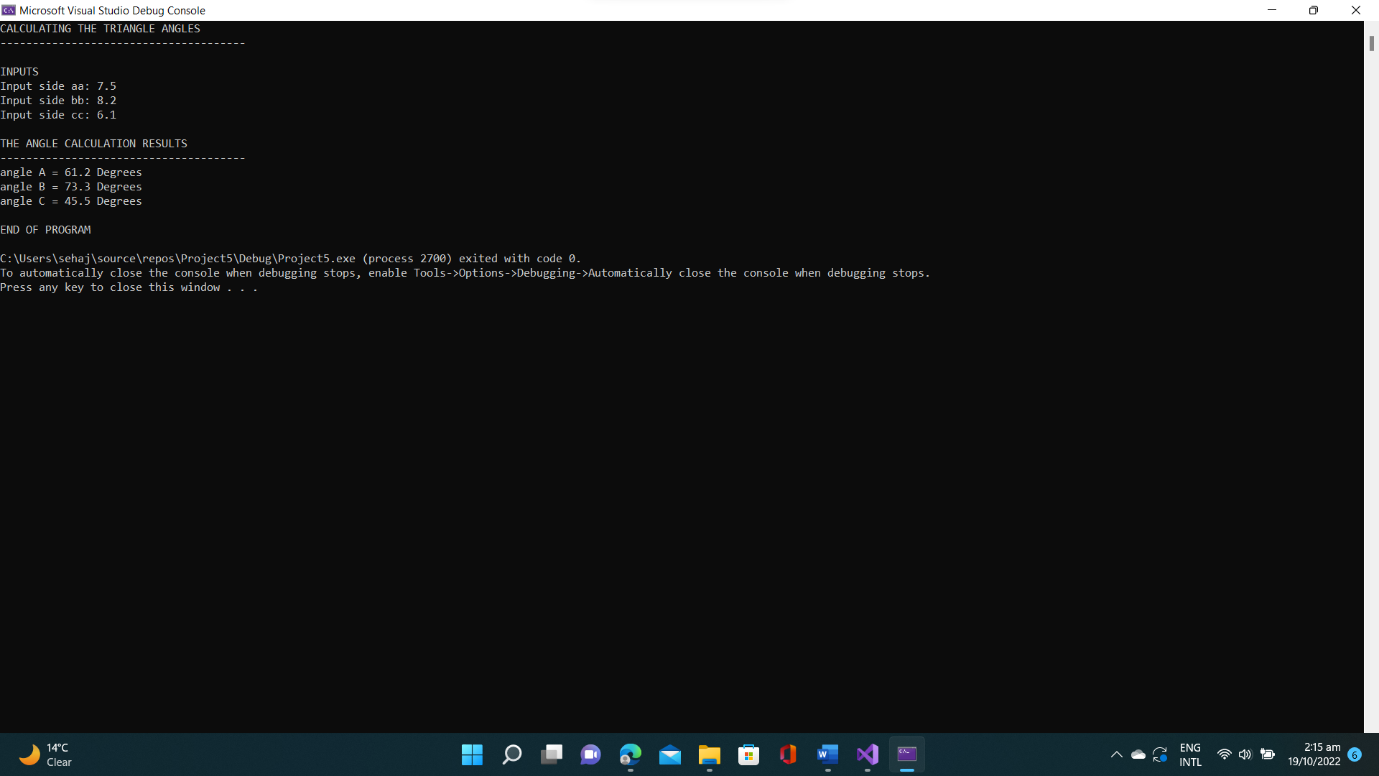

## Lab 6.2- Football World Cup 1 mark

/*****************************************  
Program title: Football World Cup   
File Name: project 24.cpp  
Author:Simarpreet singh  
Date:16/10/2022  
Description:Creating a points table for football world cup  
*****************************************/

#include<iostream>

using namespace std;

int CalculatePoints(int w, int d)//to calculate points

{

int points = (w * 3) + d;

return points;

}

int main()

{

string teamname[4] = { "France","Denmark","Peru","Australia" };//array storing names

int table[4][3] = { {2,1,0},{1,2,0},{1,0,2},{0,1,2} };//2d array to store wins loses and draws

cout << "FIFA 2018 \n Group C\n" << endl;//cout

cout << "Team W D L Pts" << endl;//column title

cout << "-------------------------------------------------------------------" << endl;

for (int i = 0; i < 4; i++)

{

if (i != 3)

{

cout << teamname[i] << "\t\t";

}

else

{

cout << teamname[i] << "\t";

}

for (int j = 0; j < 3; j++)

{

cout << table[i][j] << "\t\t";

}

cout << CalculatePoints(table[i][0], table[i][1]) << endl;//function called to get points value

}

}

## Lab 7- Task 1 2 marks

Paste the screenshot of your code output here:

/*****************************************  
Program title: File operation   
File Name: project 24.cpp  
Author:Simarpreet singh  
Date:18/10/2022  
Description:Using File operations  
*****************************************/

#include <iostream>

#include <fstream>//for files input and output

#include<string>

using namespace std;

int main()

{

ofstream file;

file.open("MyFileName.txt");//open file with file name

file << "My name is Simar singh" << endl;

file << "This is my text file" << endl;

file<< "Have a nice day" << endl;//write in the file

file.close();

return 0;

}

Paste the screenshot of your code output here:

## Lab 7- Task 2 1 mark

Paste your code here as text (not snip)

/*****************************************  
Program title: Opening file  
File Name: project 24.cpp  
Author:Simarpreet singh  
Date:18/10/2022  
Description:Opening the file in task 1 and getting outputs  
*****************************************/

#include <iostream>

#include <fstream>//for file input and output

#include<string>

using namespace std;

int main()

{

ifstream file1;

char ch;

string word;

string line;

cout << "Display the first character of the file:\n";

file1.open("MyFileName.txt");//open file

if (!file1.fail()) // if the file does not fail

{

file1.get(ch);

cout << ch << endl;

}

file1.close();//close file

//for word

ifstream file2;

file2.open("MyFileName.txt");//open file

cout << "Display the first WORD of the file:\n";

file2 >> word;

cout << word << endl;//cout the first word

file2.close(); // close file

//For single line.

ifstream file3;

file3.open("MyFileName.txt"); // open file

cout << endl << "Display line #1 of the file.\n";

getline(file3, line);

cout << line << endl;

cout << endl << "Display line #2 of the file.\n";

getline(file3, line);

cout << line << endl;

cout << endl << "Display line #3 of the file.\n";

getline(file3, line);

cout << line << endl;

file3.close(); // display all three lines of the code

return 0;

}

Paste the screenshot of your code output here:

## Lab 7- Task 3 0.5 mark

Paste your code here as text (not snip)

/*****************************************  
Program title: World population   
File Name: project 28.cpp  
Author:Simarpreet singh  
Date:19/10/2022  
Description:Using file to display countries and population  
*****************************************/

#include <iostream>

#include <fstream> // needed for file streams

#include <string>

using namespace std;

int main()

{

string countryname;

double population;//initializing variables

ifstream inFile; // input file stream

inFile.open("worldpop.txt");

if (inFile.fail())//test for if cannot open file

{

cout << "Cannot open file";

return 1;

}

cout << "Country name" << " " << "population" << endl;

cout << "------------------------------------------------" << endl;//formatting

//do while loop to display countries

do

{

inFile >> countryname >> population;

if (population >= 100000000)

{

cout << countryname << " " << population << endl;

}

} while (!inFile.eof());

return 0;

}

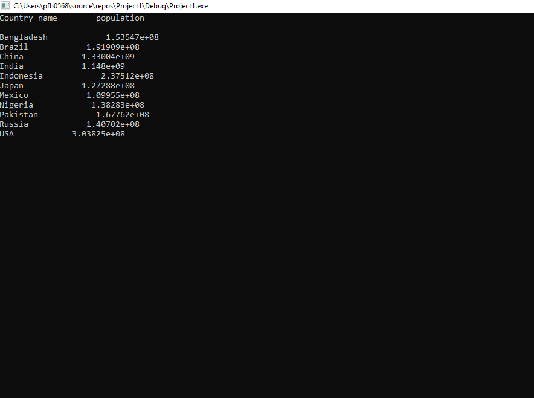

## Write up to 3 lines to explain the logic used behind this code. 0.5 marks

The code requires us to open a file named “worldpop.txt” in C++ and then from the contents of the file to display the names and population of the countries with a population which is more than or equal to 100 million , it also wants us to test if the programe is unable to open the file.

The code uses fstream which is used to input or output files in C++. The code first initializes string and double variable countryname and population respectively and then uses ifstream inFile to input a file via inFile.open(). Then an if statement is used saying if the input file fails (cant get file), then display the message “cannot open file”, this means that if the file input fails the progrrame will display this. Further after formatting cout statemtents, a do while loop is used , in which string countryname and population are allocated to the content of the used file, this do while loop contains an if statement , stating if the population of a country is more than or equal to 100 million then display the name and the population of the country , all this would run while the file has not ended using “while(!inFile.eof())”. The return statement is then used to conclude the code.